AI Model Connection Guidebook

Adding the AI model API key in the .env file
  - Either you can enter the AI model API from your paid LLM tool (openai/Anthropic/gemini etc.) OR you can use the Open Router portal (I am using the same)

Details to enter
Open the file “.env” from the final-tool folder. Below is the guide on what details to fill

AI_PROVIDER_NAME= <Enter your API Key name>
AI_API_KEY= <Enter you API KEY>

PRIMARY_MODEL=<Enter the first model name which will be used for evaluation>
FALLBACK_MODEL=<Enter the Second model name which will be used for evaluation>
SECOND_FALLBACK_MODEL=<Enter the Third model name which will be used for evaluation>

Configuring Openrouter for free option
- Open Openrouter.ai https://openrouter.ai/
- Create your account and workspace
- Go to API key generation page : https://openrouter.ai/workspaces/default/keys
- Click on New Key and enter the details (Any name can be entered and click Create)
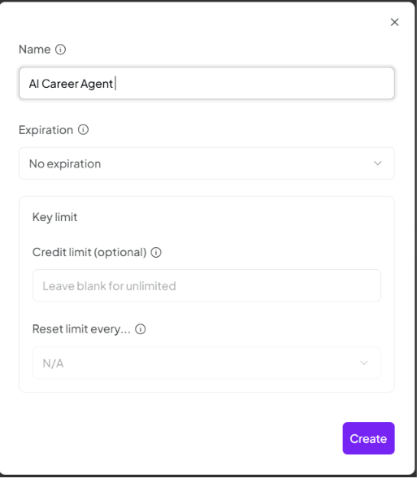
- Copy the API KEY and save it somewhere safe and use these details for the below fields
AI_PROVIDER_NAME= AI Career Agent
AI_API_KEY= sk-or-v1-*****
- Go to Model Page https://openrouter.ai/models
You can choose any free or paid model; I am using below free models currently available.
- nvidia/nemotron-3-ultra-550b-a55b:free
- google/gemma-4-26b-a4b-it:free
- nvidia/nemotron-3-super-120b-a12b:free
- Copy the model name and paste it in env file like below
PRIMARY_MODEL=nvidia/nemotron-3-ultra-550b-a55b:free
FALLBACK_MODEL=google/gemma-4-26b-a4b-it:free
SECOND_FALLBACK_MODEL=nvidia/nemotron-3-super-120b-a12b:free

Gmail Connection Guidebook

AI Career Agent

1. Purpose of this Guide
This guide explains how to connect your Gmail account to AI Career Agent so the tool can read job-alert emails and extract job links.
AI Career Agent uses Google OAuth, not your Gmail password.
You should never enter or store your Gmail password in the tool.

2. Files Used for Gmail Connection
AI Career Agent uses two important files:

2.1 credentials.json
This file comes from Google Cloud.
It identifies the local desktop app that is allowed to request Gmail access.
Expected location:
apps/gmail-agent/credentials.json
This file must be downloaded from Google Cloud.
Do not create it manually unless the tool explicitly supports manual setup.

2.2 token.json
This file is created automatically after you complete Gmail login in the browser.
Expected location:
apps/gmail-agent/token.json
You do not download this file manually.
The tool creates it after successful Google authorization.

3. Step 1 — Open Google Cloud Console
- Open Google Cloud Console in your browser https://console.cloud.google.com/
- Sign in with the Google account you want to use for Gmail job alerts.
- You may use your personal Gmail account or a dedicated job-search Gmail account.

4. Step 2 — Create or Select a Project
In Google Cloud Console:
- Click the project dropdown at the top.

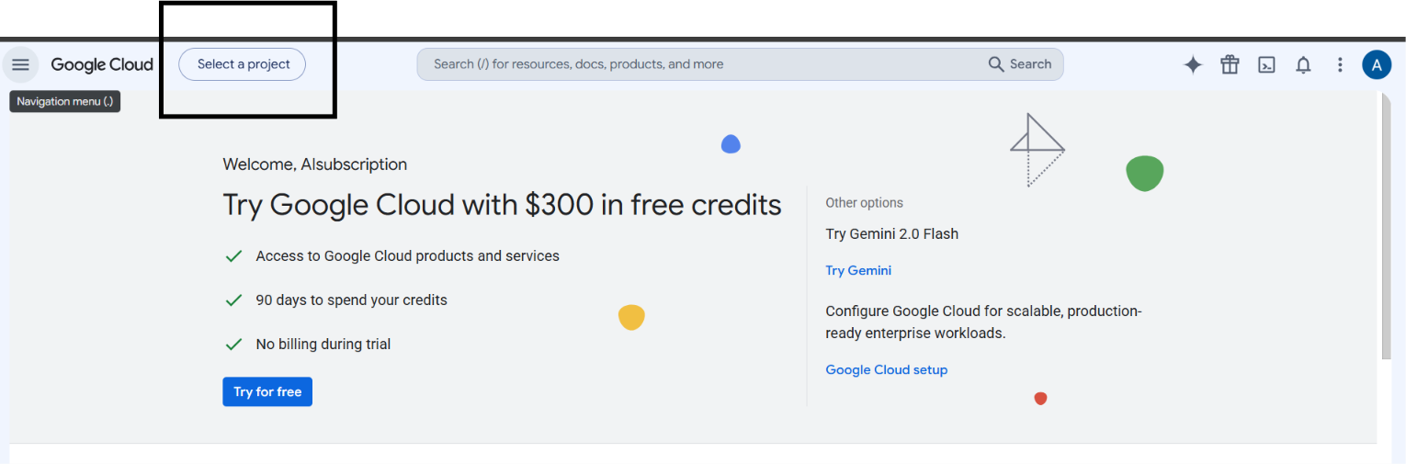
- Click on create a new project.
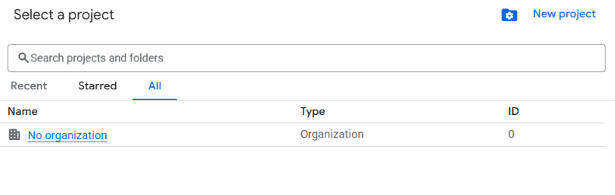
- Enter the project Name and Click Create. Suggested project name: AI Career Agent

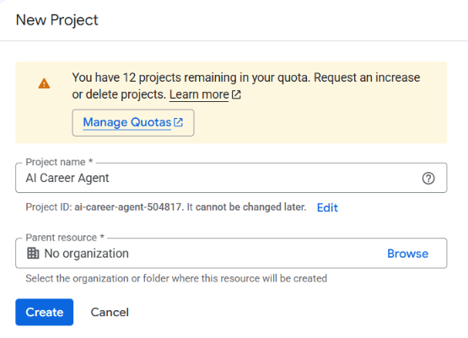

- Select the project created

5. Step 3 — Enable Gmail API
- In Google Cloud Console:
- Go to APIs & Services.
- Open Library.
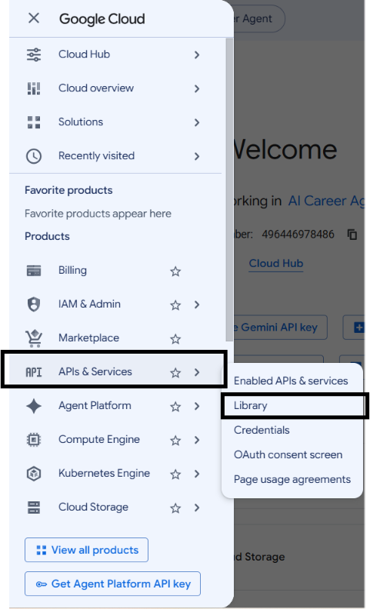
- Search for: Gmail API
- Open Gmail API.
- Click Enable.
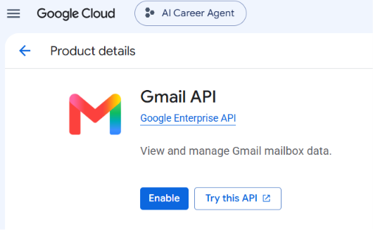

6. Step 4 — Configure OAuth Consent Screen
In Google Cloud Console:
- Go to Google Auth Platform or OAuth consent screen.
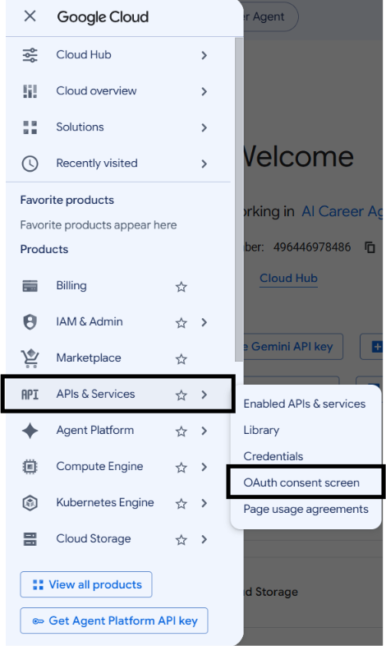
- Click on Get Started and enter below details
- Fill in the required app details:
  - App name: AI Career Agent
  - User support email: your email
  - Developer contact email: your email
- Choose user type: External for personal Gmail accounts.
- Enter your email address in contact information and then Save and continue.

7. Step 5 — Create OAuth Client ID
In Google Cloud Console:
- Go to Google Auth Platform → Clients or APIs & Services → Credentials
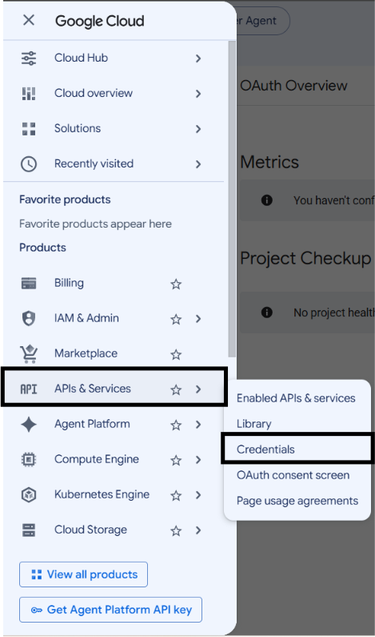
- Click Create Client or Create Credentials → OAuth client ID.
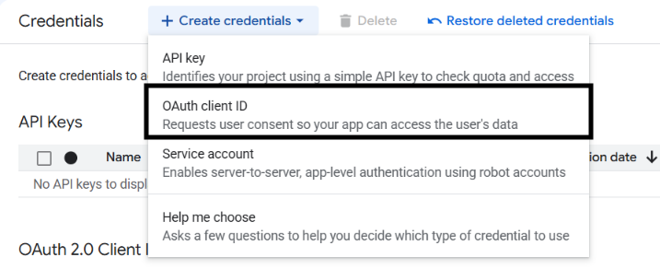
- Choose application type: Desktop app
- Name it: AI Career Agent Desktop (or you can enter any other name)
- Click Create.

8. Step 6 — Download the JSON File
After creating the Desktop OAuth client:
- Click Download JSON
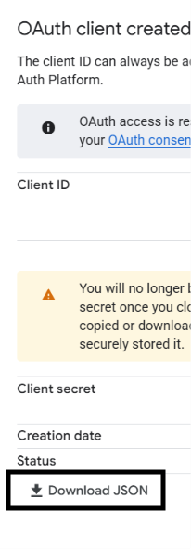
- Save the file and name it credentials. (DO NOT CHANGE THIS NAME)
- Copy the downloaded file into your AI Career Agent folder as:
apps/gmail-agent/credentials.json

9. Step 7 — Gmail Credentials in .env
Open your .env file and enter you Gmail credentials (for now keep email sender and receiver id same):
EMAIL_SENDER= <your gmail id>
EMAIL_APP_PASSWORD= <your gmail password>
EMAIL_RECEIVER= <your gmail id>

10. Step 8 — Run Gmail Reconnect
From the AI Career Agent folder, run:

Windows
python run.py
or:
.\.venv\Scripts\python.exe run.py

macOS
python3 run.py
When the menu appears, choose:
Reconnect Gmail
The browser should open and ask you to sign in to Google.
Google’s Gmail Python quickstart explains that the first run prompts the user to authorize access in the browser and then stores authorization information in token.json for future runs.

11. Step 9 — Approve Gmail Access
In the browser:
- Select the Gmail account used for job alerts.
- Review the permissions.
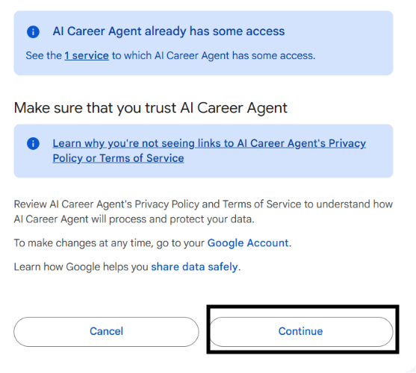
- Click Allow or Continue.
- Close the window
After successful authorization, AI Career Agent should create:
apps/gmail-agent/token.json
Then Gmail status should become:
Gmail Connection [OK]

14. How to Know Gmail Is Connected
Run:
python run.py
The startup check should show:
Gmail Connection [OK]
If it shows:
Gmail Connection [RECONNECT_REQUIRED]
choose Reconnect Gmail again.

LinkedIn connection

Opening LinkedIn Browser window
- Select Reconnect LinkedIn option
- Enter your LinkedIn Credentials once the browser window opens
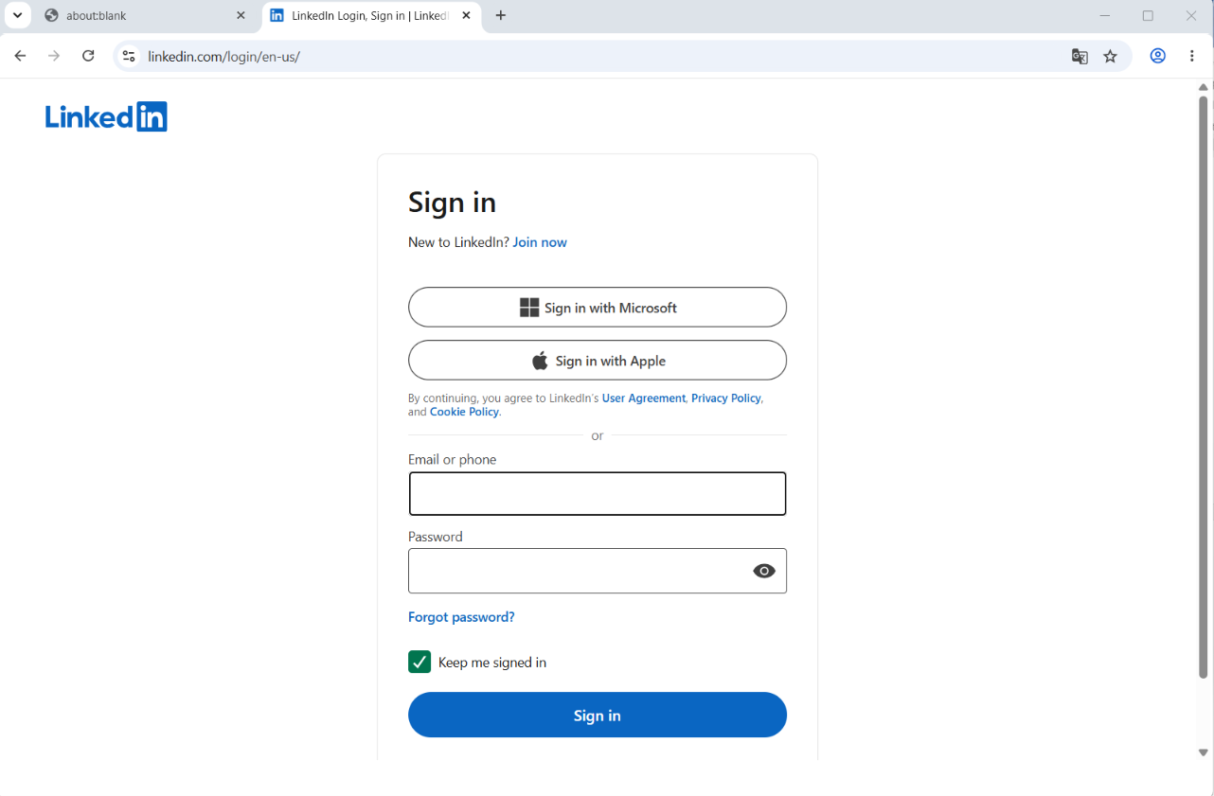
- Once the linkedIn login successful, close the window and then Press Enter
